DEPARTMENT OF INFORMATION TECHNOLOGY

LP-I LAB MANUAL (ML)

CLASS: TE-IT SEMESTER: I

SUBJECT: LABORATORY PRACTICE-I (MACHINE LEARNING) COURSE: 2019 PATTERN
ACDEMIC YEAR: 2021-22

INDEX

Sr.  No. | Content | Page no.
1 | Department vision ,Mission, Program Educational Objectives ,  Program Specific Outcomes and Program Outcomes | 3
2 | Syllabus | 5
3 | Assignment on Data preparation | 10
4 | Assignment on Regression technique | 24
5 | Assignment on Classification technique | 37
6 | Assignment on Clustering Techniques | 44
7 | Assignment of exploring Machine Learning libraries | 53

Savitribai Phule Pune University, Pune Third Year Information Technology (2019 Course) 314448 : Laboratory Practice-I (Machine Learning) |  |  | HOME
Teaching Scheme: | Credit Scheme: | Examination Scheme: | HOME
Practical (PR) : 4 hrs/week | 02 Credits | PR : 25 Marks TW: 25 Marks | HOME
Prerequisites:  1. Python programming language |  |  | HOME
Course Objectives:  - The objective of this course is to provide students with the fundamental elements of machine learning for classification, regression, clustering.  - Design and evaluate the performance of a different machine learning models. |  |  | HOME
Course Outcomes:  On completion of the course, students will be able to–  CO1: Implement different supervised and unsupervised learning algorithms.  CO2: Evaluate performance of machine learning algorithms for real-world applications. |  |  | HOME
Guidelines for Instructor's Manual |  |  | HOME
The faculty member should prepare the laboratory manual for all the experiments and it should bemade available to students and laboratory instructor/Assistant. |  |  | HOME
Guidelines for Student's Lab Journal |  |  | HOME
- Students should submit term work in the form of a handwritten journal based on specified listof assignments.  - Practical Examination will be based on the term work.  - Students are expected to know the theory involved in the experiment.  - The practical examination should be conducted if and only if the journal of the candidate is complete in all respects. |  |  | HOME
Guidelines for Lab /TW Assessment |  |  | HOME

- Examiners will assess the term work based on performance of students considering the parameters such as timely conduction of practical assignment, methodology adopted for implementation of practical assignment, timely submission of assignment in the form of handwritten write-up along with results of implemented assignment, attendance etc.
- Examiners will judge the understanding of the practical performed in the examination by asking some questions related to theory & implementation of experiments he/she has carried out.
- Appropriate knowledge of usage of software and hardware related to respective laboratories shouldbe as a conscious effort and little contribution towards Green IT and environment awareness, attaching printed papers of the program in a journal may be avoided. There must be hand-written write-ups for every assignment in the journal. The DVD/CD containing student programs should be attached to the journal by every student and the same to be maintained by the
department/lab In-charge is highly encouraged. For reference one or two journals may be maintained with program prints at Laboratory.

Guidelines for Laboratory Conduction
- All the assignments should be implemented using python programming language
- Implement any 4 assignments out of 6
- Assignment clustering with K-Means is compulsory
- The instructor is expected to frame the assignments by understanding the prerequisites, technological aspects, utility and recent trends related to the topic.
- The instructor may frame multiple sets of assignments and distribute them among batches of students.
- All the assignments should be conducted on multicore hardware and 64-bit open-sources software
Guidelines for Practical Examination
- Both internal and external examiners should jointly set problem statements for practical examination. During practical assessment, the expert evaluator should give the maximum weightage to the satisfactory implementation of the problem statement.
- The supplementary and relevant questions may be asked at the time of evaluation to judge the student ‘s understanding of the fundamentals, effective and efficient implementation.
- The evaluation should be done by both external and internal examiners.
List of Laboratory Assignments

Sr.No. | Practical List
1 | Data Preparation:  Download heart dataset from following link. https://www.kaggle.com/zhaoyingzhu/heartcsv  Perform following operation on given dataset.  - Find Shape of Data  - Find Missing Values  - Find data type of each column  - Finding out Zero's  - Find Mean age of patients  - Now extract only Age, Sex, ChestPain, RestBP, Chol. Randomly divide dataset in training (75%) and testing (25%).  Through the diagnosis test I predicted 100 report as COVID positive, but only 45 of those were actually positive. Total 50 people in my sample were actually COVID positive. I have total 500 samples.  Create confusion matrix based on above data and find I I. Accuracy  - II. Precision  - III. Recall  IV. F-1 score
2 | Assignment on Regression technique  a. Apply Linear Regression using suitable library function and predict the Month-wise  Download temperature data from below link. https://www.kaggle.com/venky73/temperatures- of- india?select=temperatures.csv  This data consists of temperatures of INDIA averaging the temperatures of all places month wise. Temperatures values are recorded in CELSIUS temperature. b. Assess the performance of regression models using MSE, MAE and R-Square metrics c. Visualize simple regression model
3 | Assignment on Classification technique  Every year many students give the GRE exam to get admission in foreign Universities. The data set contains GRE Scores (out of 340), TOEFL Scores (out of 120), University Rating (out of 5), Statement of Purpose strength (out of 5), Letter of Recommendation strength (out of 5), Undergraduate GPA (out of 10), Research Experience (0=no, 1=yes), Admitted (0=no, 1=yes). Admitted is the target variable.  Data Set Available on kaggle (The last column of the dataset needs to be changed to 0 or 1)Data Set : https://www.kaggle.com/mohansacharya/graduate-admissions  The counselor of the firm is supposed check whether the student will get an admission or not based on

his/her GRE score and Academic Score. So to help the counselor to take appropriate decisions build a machine learning model classifier using Decision tree to predict whether a student will get admission or not.
Apply Data pre-processing (Label Encoding, Data Transformation….) techniques if necessary. Perform data-preparation (Train-Test Split)
C. Apply Machine Learning Algorithm
D. Evaluate Model.
4 | Assignment on Improving Performance of Classifier Models  - Apply Data pre-processing (Label Encoding, Data Transformation….) techniques if necessary  - Perform data-preparation (Train-Test Split)  - Apply at least two Machine Learning Algorithms and Evaluate Models  - Apply Cross-Validation and Evaluate Models and compare performance.  - Apply Hyper parameter tuning and evaluate models and compare performance.  A SMS unsolicited mail (every now and then known as cell smartphone junk mail) is any junk message brought to a cellular phone as textual content messaging via the Short Message Service (SMS). Use probabilistic approach (Naive Bayes Classifier / Bayesian Network) to implement SMS Spam Filtering system. SMS messages are categorized as SPAM or HAM using features like length of message, word depend, unique keywords etc.  Download Data -Set from : http://archive.ics.uci.edu/ml/datasets/sms+spam+collection  This dataset is composed by just one text file, where each line has the correct class followed by the raw message
5 | Assignment on Clustering Techniques  Download the following customer dataset from below link: Data Set: https://www.kaggle.com/shwetabh123/mall-customer  This dataset gives the data of Income and money spent by the customers visiting a Shopping Mall. The data set contains Customer ID, Gender, Age, Annual Income, Spending Score. Therefore, as a mall owner you need to find the group of people who are the profitable customers for the mall owner. Apply at least two clustering algorithms (based on Spending Score) to find the group of customers.  - Apply Data pre-processing (Label Encoding , Data Transformation….) techniques if necessary.  - Perform data-preparation( Train-Test Split)  - Apply Machine Learning Algorithm  - Evaluate Model.  - Apply Cross-Validation and Evaluate Model.
6 | Assignment on Association Rule Learning  Download Market Basket Optimization dataset from below link.  Data Set: https://www.kaggle.com/hemanthkumar05/market-basket-optimization

This dataset comprises the list of transactions of a retail company over the period of one week. It contains a total of 7501 transaction records where each record consists of the list of items sold in one transaction. Using this record of transactions and items in each transaction, find the association rules between items. There is no header in the dataset and the first row contains the first transaction, so mentioned header = None here while loading dataset.
- Follow following steps :
- Data Preprocessing
- Generate the list of transactions from the dataset
- Train Apriori algorithm on the dataset
- Visualize the list of rules
F. Generated rules depend on the values of hyper parameters. By increasing the minimum confidence value and find the rules accordingly.
7 | Assignment on Multilayer Neural Network Model  - Load the dataset in the program. Define the ANN Model with Keras. Define at least two hidden layers. Specify the ReLU function as activation function for the hidden layer and Sigmoid for the output layer.  - Compile the model with necessary parameters. Set the number of epochs and batch size and fit the model.  - Evaluate the performance of the model for different values of epochs and batch sizes.  - Evaluate model performance using different activation functions Visualize the model using ANN Visualizer.  Download the dataset of National Institute of Diabetes and Digestive and Kidney Diseases from below link :  Data Set: https://raw.githubusercontent.com/jbrownlee/Datasets/master/pima-indians- diabetes.data.csv The dataset is has total 9 attributes where the last attribute is “Class attribute” having values 0  and 1. (1=”Positive for Diabetes”, 0=”Negative”)

Aim:

Assignment 1

Data Preparation: Download heart dataset from following link. https://www.kaggle.com/zhaoyingzhu/heartcsv
Perform following operation on given dataset.
- Find Shape of Data
- Find Missing Values
- Find data type of each column
- Finding out Zero's
- Find Mean age of patients
- Now extract only Age, Sex, ChestPain, RestBP, Chol. Randomly divide dataset in training (75%) and testing (25%).

Through the diagnosis test I predicted 100 report as COVID positive, but only 45 of those were actually positive. Total 50 people in my sample were actually COVID positive. I have total 500 samples.
Create confusion matrix based on above data and find I Accuracy
- Precision
- Recall
- F-1 score

Theory:
Data Preparation: It is the process of transforming raw data into a particular form so that data scientists and analysts can run it through machine learning algorithms to uncover insights or make predictions. All projects have the same general steps; they are:
Step 1: Define Problem. Step 2: Prepare Data.
Step 3: Evaluate Models.
Step 4: Finalize Model.
We are concerned with the data preparation step (step 2), and there are common or standard tasks that you may use or explore during the data preparation step in a machine learning project.

Data Preparation Tasks

- Data Cleaning: There are many reasons data may have incorrect values, such as being mistyped, corrupted, duplicated, and so on. Domain expertise may allow obviously erroneous observations to be identified as they are different from what is expected.

- Feature Selection: Feature selection refers to techniques for selecting a subset of input features that are most relevant to the target variable that is being predicted. Feature selection techniques are generally grouped into those that use the target variable (supervised) and those that do not (unsupervised). Additionally, the supervised techniques can be further divided into models that automatically select features as part of fitting the model (intrinsic), those that explicitly choose features that result in the best performing model (wrapper) and those that score each input feature and allow a subset to be selected (filter).
- Data Transforms: Data transforms are used to change the type or distribution of data variables.
  - Numeric Data Type: Number values.
  - Integer: Integers with no fractional part.
  - Real: Floating point values.
  - Categorical Data Type: Label values.
  - Ordinal: Labels with a rank ordering.
  - Nominal: Labels with no rank ordering.
  - Boolean: Values True and False.

- Feature Engineering: Feature engineering refers to the process of creating new input variables from the available data. Engineering new features is highly specific to your data and data types. As such, it often requires the collaboration of a subject matter expert to help identify new features that could be constructed from the data.

- Dimensionality Reduction: The number of input features for a dataset may be considered the dimensionality of the data. This motivates feature selection, although an alternative to feature selection is to create a projection of the data into a lower-dimensional space that still preserves the most important properties of the original data. The most common approach to dimensionality reduction is to use a matrix factorization technique:

- Principal Component Analysis (PCA)
- Linear Discriminant Analysis (LDA)

Confusion Matrix
A Confusion matrix is an N x N matrix used for evaluating the performance of a classification model, where N is the number of target classes. The matrix compares the actual target values with those predicted by the machine learning model.

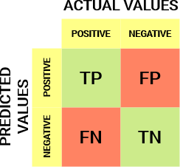

The explanation of the terms associated with confusion matrix is as follows −
  - True Positives (TP) − It is the case when both actual class & predicted class of data point is 1.
  - True Negatives (TN) − It is the case when both actual class & predicted class of data point is 0.
  - False Positives (FP) − It is the case when actual class of data point is 0 & predicted class of data point is 1.
  - False Negatives (FN) − It is the case when actual class of data point is 1 & predicted class of data point is 0.
Code:

#Imporiting Required Libraries
#converting an entire data table into a NumPy matrix array. #data manipulation and analysis
import pandas as pd
importnumpy as np#array manipulation importmatplotlib.pyplot as plt#graph plotting libraries
importseaborn as sns#data visualization and exploratory data analysis. #making statistical graphics.
#%matplotlib inline #Loading the data
#Data frame is a two-dimensional data structure,
#i.e., data is aligned in a tabular fashion in rows and columns.

df = pd.read_csv('heart.csv') # read csv file store into dataframedf print(df.head(3)) # print first 3 row, if df print complete data print() #print for spacing
#Features of the data set
print('Below are the features of dataset:') df.info()
#Details of Rows & Columns (Count, Datatypes, Null Values & Memory Usage) #Dimensions of the dataset
print()
print('Below are the diamensions of dataset:') #Shape method denotes count of rows &colums print('Number of rows in the dataset: ',df.shape[0])
print('Number of columns in the dataset: ',df.shape[1]) #Checking for null values in the dataset
print()
print('Checking for null values in the dataset:') print(df.isnull().sum()) #Field has no value present #There are no null values in the dataset print(df.describe())
#The features described in the above data set are:
#1. Count tells us the number of NoN-empty rows in a feature. #2. Mean tells us the mean value of that feature.
#3. Std tells us the Standard Deviation Value of that feature.

#4. Min tells us the minimum value of that feature.
#5. 25%, 50%, and 75% are the percentile/quartile of each features. #6. Max tells us the maximum value of that feature.
#Checking features of various attributes #1. Sex -->
male =len(df[df['sex'] == 1]) #df=complete df #df = column in df female = len(df[df['sex']== 0])
plt.figure(figsize=(8,6)) #8 by 6 inch # Data to plot specifications
labels = 'Male','Female' sizes = [male,female]
colors = ['skyblue', 'yellowgreen']
explode = (0, 0) # explode 1st slice don't separate # Plot actual figure
#autopct: according len calculate percentage #pie: show piechart according parameter
plt.pie(sizes, explode=explode, labels=labels, colors=colors, autopct='%1.1f%%', shadow=True, startangle=90) plt.axis('equal') #x & y equal axis
plt.show()
#2. Chest Pain Type --> plt.figure(figsize=(8,6)) # Data to plot

labels = 'Chest Pain Type:0','Chest Pain Type:1','Chest Pain Type:2','Chest Pain Type:3' sizes = [len(df[df['cp'] == 0]),len(df[df['cp'] == 1]),
len(df[df['cp'] == 2]),
len(df[df['cp'] == 3])]
colors = ['skyblue', 'yellowgreen','orange','gold'] explode = (0, 0,0,0) # explode 1st slice
# Plot specifications
plt.pie(sizes, explode=explode, labels=labels, colors=colors, autopct='%1.1f%%', shadow=True, startangle=180) plt.axis('equal')
plt.show()
#3. fbs: (fasting blood sugar > 120 mg/dl) (1 = true; 0 = false) plt.figure(figsize=(8,6))
# Data to plot
labels = 'fasting blood sugar < 120 mg/dl','fasting blood sugar > 120 mg/dl' sizes = [len(df[df['fbs'] == 0]),len(df[df['cp'] == 1])] #bp value
colors = ['skyblue', 'yellowgreen','orange','gold'] explode = (0.1, 0) # explode 1st slice
# Plot
plt.pie(sizes, explode=explode, labels=labels, colors=colors, autopct='%1.1f%%', shadow=True, startangle=180) plt.axis('equal')
plt.show()

#4.exang: exercise induced angina (1 = yes; 0 = no) plt.figure(figsize=(8,6))
# Data to plot labels = 'No','Yes'
sizes = [len(df[df['exang'] == 0]),len(df[df['exang'] == 1])] colors = ['skyblue', 'yellowgreen']
explode = (0.1, 0) # explode 1st slice # Plot
plt.pie(sizes, explode=explode, labels=labels, colors=colors, autopct='%1.1f%%', shadow=True, startangle=90) plt.axis('equal')
plt.show()
#Exploratory Data Analysis sns.set_style('whitegrid') #set background white #1. Heatmap
plt.figure(figsize=(14,8)) #14/8
#heatmap:Graphical representation of data that uses a system of #color-coding to represent different values
#corr(): pairwise correlation of all columns in the dataframe #annot: Value in each field bool or rectangular dataset #cmap: Colourmap
sns.heatmap(df.corr(), annot = True, cmap='coolwarm',linewidths=.1) plt.show()

#Plotting the distribution of various attribures #1. thalach: maximum heart rate achieved
sns.distplot(df['thalach'],kde=False,bins=30,color='violet') #2.chol: serum cholestoral in mg/dl sns.distplot(df['chol'],kde=False,bins=30,color='red') plt.show()
#3. trestbps: resting blood pressure (in mm Hg on admission to the hospital) sns.distplot(df['trestbps'],kde=False,bins=30,color='blue')
plt.show()
#4. Number of people who have heart disease according to age plt.figure(figsize=(15,6))
sns.countplot(x='age',data = df, hue = 'target',palette='GnBu') plt.show()
#5.Scatterplot for thalach vs. chol plt.figure(figsize=(8,6)) sns.scatterplot(x='chol',y='thalach',data=df,hue='target') plt.show()
#6.Scatterplot for thalach vs. trestbps plt.figure(figsize=(8,6)) sns.scatterplot(x='trestbps',y='thalach',data=df,hue='target') plt.show()
#Making Predictions
#Splitting the dataset into training and test set

X= df.drop('target',axis=1) y=df['target']
fromsklearn.model_selection import train_test_split
X_train,X_test,y_train,y_test = train_test_split(X,y,test_size=.3,random_state=42) #Preprocessing - Scaling the features
fromsklearn.preprocessing import StandardScaler scaler = StandardScaler()
X_train_scaled = scaler.fit_transform(X_train) X_train = pd.DataFrame(X_train_scaled) X_test_scaled = scaler.transform(X_test) X_test = pd.DataFrame(X_test_scaled)
#1. k-NearestNeighor Algorithm
#ImplementingGridSearchCv to select best parameters and applying k-NN Algorithm fromsklearn.neighbors import KNeighborsClassifier
fromsklearn.model_selection import GridSearchCV knn =KNeighborsClassifier()
params = {'n_neighbors':list(range(1,20)), 'p':[1, 2, 3, 4,5,6,7,8,9,10],
'leaf_size':list(range(1,20)), 'weights':['uniform', 'distance'] }
model = GridSearchCV(knn,params,cv=3, n_jobs=-1) model.fit(X_train,y_train)
print(model.best_params_) #print's parameters best values

#Making predictions
predict = model.predict(X_test) #Checking accuracy
fromsklearn.metrics import accuracy_score,confusion_matrix print()
print('Accuracy Score: ',accuracy_score(y_test,predict)) print('Using k-NN we get an accuracy score of: ', round(accuracy_score(y_test,predict),5)*100,'%') print()
#Confusion Matrix class_names = [0,1] fig,ax = plt.subplots()
tick_marks = np.arange(len(class_names)) plt.xticks(tick_marks,class_names) plt.yticks(tick_marks,class_names) cnf_matrix = confusion_matrix(y_test,predict) print('Below is the confusion matrix') print(cnf_matrix)
#create a heat map
sns.heatmap(pd.DataFrame(cnf_matrix), annot = True, cmap = 'YlGnBu',fmt = 'g') ax.xaxis.set_label_position('top')
plt.tight_layout()
plt.title('Confusion matrix for k-Nearest Neighbors Model', y = 1.1)

plt.ylabel('Actual label') plt.xlabel('Predicted label') plt.show()
#Classification report
fromsklearn.metrics import classification_report print(classification_report(y_test,predict)) #Receiver Operating Characterstic(ROC) Curve
fromsklearn.metrics import roc_auc_score,roc_curve #Get predicted probabilites from the model y_probabilities = model.predict_proba(X_test)[:,1] #Create true and false positive rates
false_positive_rate_knn,true_positive_rate_knn,threshold_knn = roc_curve(y_test,y_probabilities) #Plot ROC Curve
plt.figure(figsize=(10,6))
plt.title('Revceiver Operating Characterstic') plt.plot(false_positive_rate_knn,true_positive_rate_knn) plt.plot([0,1],ls='--')
plt.plot([0,0],[1,0],c='.5')
plt.plot([1,1],c='.5') plt.xlabel('False Positive Rate') plt.ylabel('True Positive Rate') plt.show()
#Calculate area under the curve

print(roc_auc_score(y_test,y_probabilities))
Output:
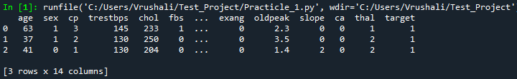
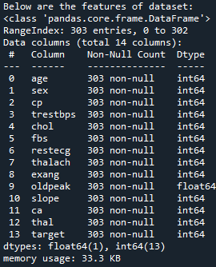
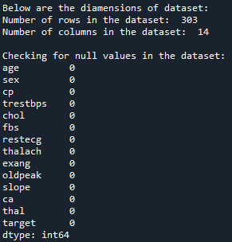
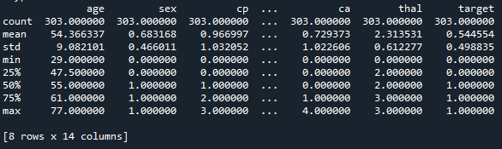

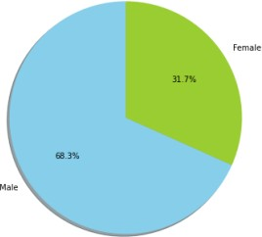
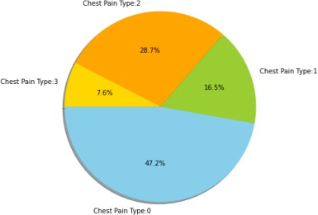
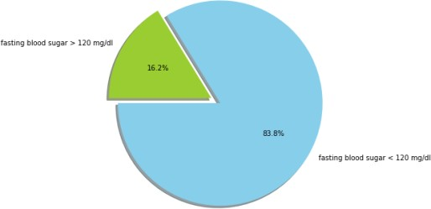
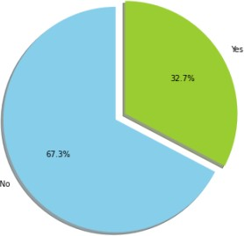
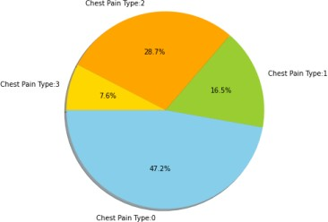
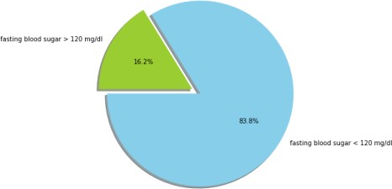
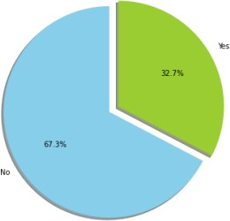
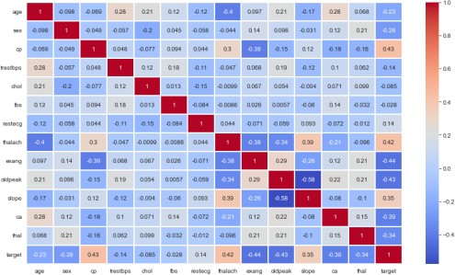
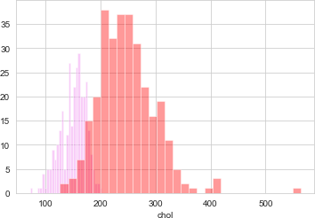
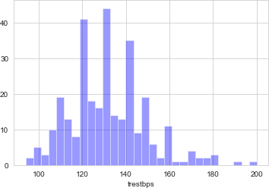
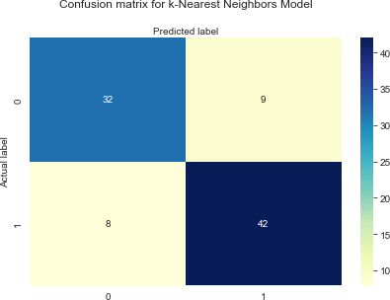

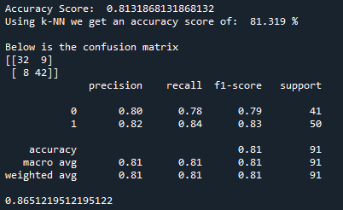

Conclusion: Thus we have studied different data preparation techniques.

ASSIGNMENT 2
Aim:

Assignment on Classification technique
Every year many students give the GRE exam to get admission in foreign Universities. The data set contains GRE Scores (out of 340), TOEFL Scores (out of 120), University Rating (out of 5), Statement of Purpose strength (out of 5), Letter of Recommendation strength (out of 5), Undergraduate GPA (out of 10), Research Experience (0=no, 1=yes), Admitted (0=no, 1=yes). Admitted is the target variable. Data Set Available on kaggle (The last column of the dataset needs to be changed to 0 or 1)Data Set : https://www.kaggle.com/mohansacharya/graduate-admissions The counselor of the firm is supposed check whether the student will get an admission or not based on his/her GRE score and Academic Score. So to help the counselor to take appropriate decisions build a machine learning model classifier using Decision tree to predict whether a student will get admission or not. Apply Data pre-processing (Label Encoding, Data Transformation….) techniques if necessary. Perform data-preparation (Train-Test Split)
C. Apply Machine Learning Algorithm D. Evaluate Model.
Theory:
Classification: Classification may be defined as the process of predicting class or category from observed values or given data points. The categorized output can have the form such as “Black” or “White” or “spam” or “no spam”.Mathematically, classification is the task of approximating a mapping function (f) from input variables (X) to output variables (Y).

Building a Classifier in Python:

Step1: Importing necessary python package Step2: Importing dataset
Step3: Organizing data into training & testing sets Step4: Model evaluation
Step5: Finding accuracy

Classification Algorithms Include:

Naive Bayes, Logistic regression, K-nearest neighbours, (Kernel) SVM, Decision tree

- Logistic Regression Algorithm: It is a Machine Learning classification algorithm that is used to predict the probability of a categorical dependent variable. In logistic regression, the dependent variable is a binary variable that contains data coded as 1 (yes, success, etc.) or 0 (no, failure, etc.). Logistic regression model predicts P(Y=1) as a function of X.
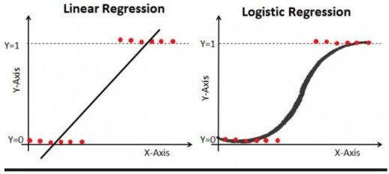

Logistic Regression Algorithm Equation:

The Logistic regression equation can be obtained from the Linear Regression equation. The mathematical steps to get Logistic Regression equations are given below:

  - We know the equation of the straight line can be written as:
  - In Logistic Regression y can be between 0 and 1 only, so for this let's divide the above equation by (1-y):

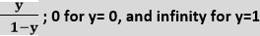
  - But we need range between -[infinity] to +[infinity], then take logarithm of the equation it will become:
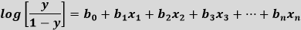

The above equation is the final equation for Logistic Regression.

Steps in Logistic Regression: To implement the Logistic Regression using Python, we will use the same steps as we have done in previous topics of Regression. Below are the steps:

- Data Pre-processing step
- Fitting Logistic Regression to the Training set
- Predicting the test result
- Test accuracy of the result(Creation of Confusion matrix)
- Visualizing the test set result.

- Decision Tree Algorithm: Decision trees can be constructed by an algorithmic approach that can split the dataset in different ways based on different conditions. Decisions tress is the most powerful algorithms that falls under the category of supervised algorithms.

Decision Tree Algorithm Steps:

Step-1: Begin the tree with the root node, says S, which contains the complete dataset. Step-2: Find the best attribute in the dataset using Attribute Selection Measure (ASM). Step-3: Divide the S into subsets that contains possible values for the best attributes.
Step-4: Generate the decision tree node, which contains the best attribute.

Step-5: Recursively make new decision trees using the subsets of the dataset created in step -3. Continue this process until a stage is reached where you cannot further classify the nodes and called the final node as a leaf node.

Solve decision tree such problems there is a technique which is called as Attribute selection measure or ASM. There are two popular techniques for ASM, which are:

  - Information Gain: Information gain is the measurement of changes in entropy after the segmentation of a dataset based on an attribute. It calculates how much information a feature provides us about a class. According to the value of information gain, we split the node and build the decision tree.

Information Gain= Entropy(S)- [(Weighted Avg) *Entropy(each feature)

  - Entropy: Entropy is a metric to measure the impurity in a given attribute. It specifies randomness in data. Entropy can be calculated as:

Entropy(s)= -P(yes)log2 P(yes)- P(no) log2 P(no) Where,S= Total number of samples, P(yes)= probability of yes, P(no)= probability of no
  - Gini Index: Gini index is a measure of impurity or purity used while creating a decision tree in the CART(Classification and Regression Tree) algorithm. An attribute with the low Gini index should be preferred as compared to the high Gini index.

Gini Index= 1- ∑jPj2

- SVM Algorithm: Support Vector Machine or SVM is one of the most popular Supervised Learning algorithms, which is used for Classification as well as Regression problems.The goal of the SVM algorithm is to create the best line or decision boundary that can segregate n-dimensional space into classes so that we can easily put the new data point in the correct category in the future. This best decision boundary is called a hyperplane.SVM chooses the extreme points/vectors that help in creating the hyperplane. These extreme cases are called as support vectors, and hence algorithm is termed as Support Vector Machine. Consider the below diagram in which there are two different categories that are classified using a decision boundary or hyperplane.
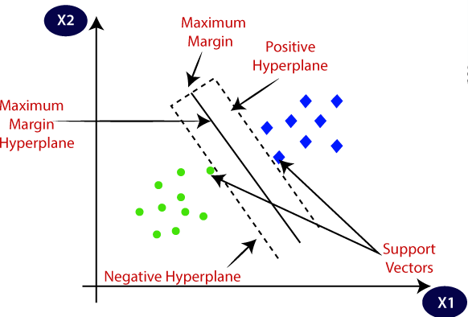

SVM Algorithm Steps:

  - Importing the dataset
  - Splitting the dataset into training and test samples
  - Classifying the predictors and target
  - Initializing Support Vector Machine and fitting the training data
  - Predicting the classes for test set
  - Attaching the predictions to test set for comparing
  - Comparing the actual classes and predictions

  - Calculating the accuracy of the predictions

Applications of Classifications Algorithms:

Sentiment Analysis
- Email Spam Classification

Document Classification
- Image Classification

Code:
# To load the dataset import pandas as pd
importmatplotlib.pyplot as plt
#seaborn: for data visualization and exploratory data analysis importseaborn as sns
import warnings warnings.filterwarnings("ignore")
#Read data in csv file store into dataframe df = pd.read_csv('Admission_Predict.csv') print(df.head(5))
##########################################################################
#To drop the irrelevant column and check if there are any null values in the dataset df = df.drop(['Serial No.'], axis=1)
print(df.isnull().sum())
#To see the distribution of the variables of graduate applicants. #distplot() plot distributed data as observations

#KDE: Kerner Density Estimate, probability density function of a continuous random variable Show GRE Score
fig = sns.distplot(df['GRE Score'], kde=False) plt.title("Distribution of GRE Scores") plt.show()
#Show TOEFL Score
fig = sns.distplot(df['TOEFL Score'], kde=False) plt.title("Distribution of TOEFL Scores") plt.show()
#Show University Ratings
fig = sns.distplot(df['University Rating'], kde=False) plt.title("Distribution of University Rating") plt.show()
#Show SOP Ratings
fig = sns.distplot(df['SOP'], kde=False) plt.title("Distribution of SOP Ratings") plt.show()
#Show CGPA
fig = sns.distplot(df['CGPA'], kde=False) plt.title("Distribution of CGPA") plt.show()
#It is clear from the distributions, students with varied merit apply for the university.
#Understanding the relation between different factors responsible for graduate admissions GRE Score vs TOEFL Score

#regplot() :Plot data and a linear regression model fit.
fig = sns.regplot(x="GRE Score", y="TOEFL Score", data=df) plt.title("GRE Score vs TOEFL Score")
plt.show()
#People with higher GRE Scores also have higher TOEFL Scores which is justified because both TOEFL and GRE have a verbal section which although not similar are relatable
#GRE Score vs CGPA
fig = sns.regplot(x="GRE Score", y="CGPA", data=df) plt.title("GRE Score vs CGPA")
plt.show()
#Although there are exceptions, people with higher CGPA usually have higher GRE scores maybe because they are smart or hard working
#LOR vs CGPA show wheather Research 0 or 1
#lmplot():a 2D scatterplot with an optional overlaid regression line.
#hue: Variables that define subsets of the data, which will be drawn on separate facets in the grid. fig = sns.lmplot(x="CGPA", y="LOR ", data=df, hue="Research")
plt.title("LOR vs CGPA") plt.show()
#LORs (Letter of Recommendation strength) are not that related with CGPA so it is clear that a persons LOR is not dependent on that persons academic excellence.
#Having research experience is usually related with a good LOR which might be justified by the fact that supervisors have personal interaction with the students performing research which usually results in good LORs
#GRE Score vs LOR SHOW WHEATHER Research 0 or 1
fig = sns.lmplot(x="GRE Score", y="LOR ", data=df, hue="Research")

plt.title("GRE Score vs LOR") plt.show()
#GRE scores and LORs are also not that related. People with different kinds of LORs have all kinds of GRE scores
#SOP vs CGPA
fig = sns.regplot(x="CGPA", y="SOP", data=df) plt.title("SOP vs CGPA")
plt.show()
#CGPA and SOP are not that related because Statement of Purpose is related to academic performance, but since people with good CGPA tend to be more hard working so they have good things to say in their SOP which might explain the slight move towards higher CGPA as along with good SOPs
#GRE Score vs SOP
fig = sns.regplot(x="GRE Score", y="SOP", data=df) plt.title("GRE Score vs SOP")
plt.show()
#Similary, GRE Score and CGPA is only slightly related #SOP vs TOEFL
fig = sns.regplot(x="TOEFL Score", y="SOP", data=df) plt.title("SOP vs TOEFL")
plt.show()
.#Correlation among variables importnumpy as np
#corr():Find the pairwise correlation of all columns in the dataframe corr = df.corr()

print(corr)
#plt.subplot:Crate a figure & set sub plots fig, ax = plt.subplots(figsize=(8, 8))
#Make a diverging palette between two HUSL colors. #cmap: colour map set
colormap = sns.diverging_palette(220, 10, as_cmap=True)
#zeros_like():Returns an array of given shape and type as given array, with zeros. dropSelf = np.zeros_like(corr)
#np.triu_indices_from(dropSelf): Return indices of array dropSelf[np.triu_indices_from(dropSelf)] = True colormap = sns.diverging_palette(220, 10, as_cmap=True)
sns.heatmap(corr, cmap=colormap, linewidths=.5, annot=True, fmt=".2f", mask=dropSelf) plt.show()
fromsklearn.model_selection import train_test_split #drop col chances of admission
X = df.drop(['Chance of Admit '], axis=1) y = df['Chance of Admit ']
#split data for training & tasting
X_train, X_test, y_train, y_test = train_test_split(X,y,test_size = 0.20, shuffle=False) #DecisionTree, Random Forest, K Neighbor, SVR, Linear Regression fromsklearn.tree import DecisionTreeRegressor
fromsklearn.ensemble import RandomForestRegressor fromsklearn.svm import SVR

fromsklearn.linear_model import LinearRegression fromsklearn.metrics import mean_squared_error
#These methods predict the future applicant's chances of admission. models = [['DecisionTree :',DecisionTreeRegressor()],
['Linear Regression :', LinearRegression()], ['SVM :', SVR()]]
print("Results...")
#For loop for generating model results forname,model in models:
model = model
#Fit training data of x & y axis model.fit(X_train, y_train) #Pass predicted or test result
predictions = model.predict(X_test)
#Difference between actual value & predicted value print(name, (np.sqrt(mean_squared_error(y_test, predictions)))) classifier = RandomForestRegressor()
classifier.fit(X,y)
#X.columns features in dataset feature_names = X.columns print(feature_names)
#Initialize importance_frame[] in 2 dim array. importance_frame = pd.DataFrame()

#Two Dimensional Array Format column names importance_frame['Features'] = X.columns
#classifier.feature_importance is decision tree based on correlation value As per importance of admission importance_frame['Importance'] = classifier.feature_importances_
#Sort the features by high to low bar graph
importance_frame = importance_frame.sort_values(by=['Importance'], ascending=True) #Visualize 7 Feature Importances
#bar: plots horizontal rectangles with constant heights.
plt.barh([1,2,3,4,5,6,7], importance_frame['Importance'], align='center', alpha=0.5) #yticks: set feature lable on y axis
plt.yticks([1,2,3,4,5,6,7], importance_frame['Features']) plt.xlabel('Importance')
#Clearly, CGPA is the most factor for graduate admissions followed by GRE Score. plt.title('Feature Importances')
plt.show()
Output:
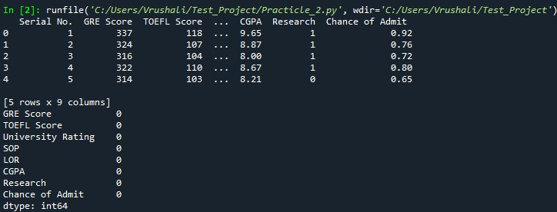

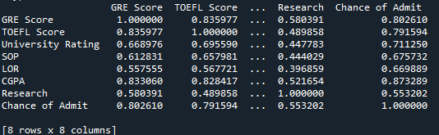

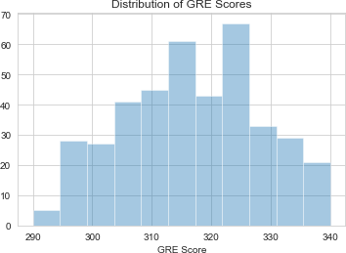
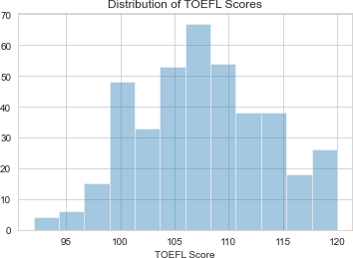
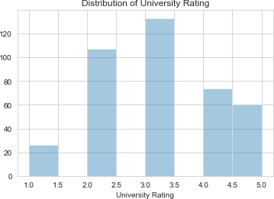

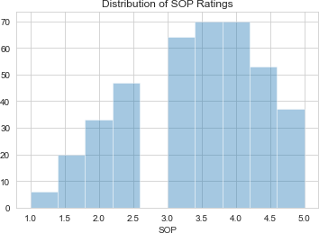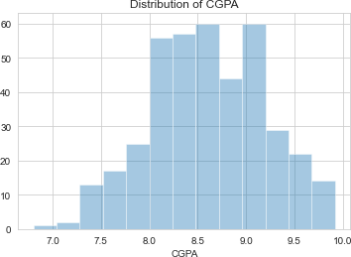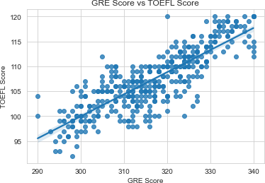

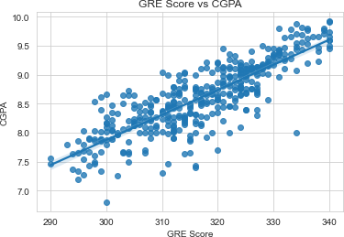
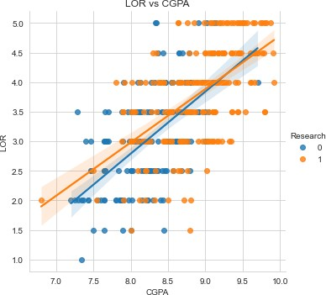
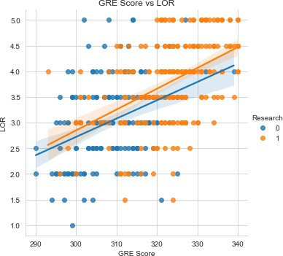

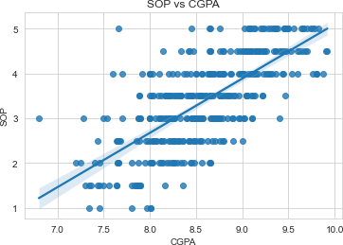
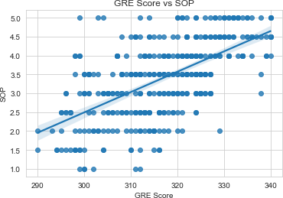
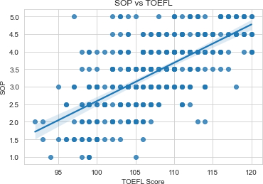
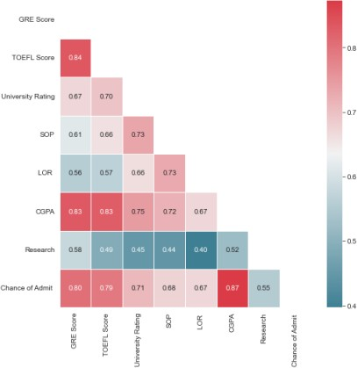
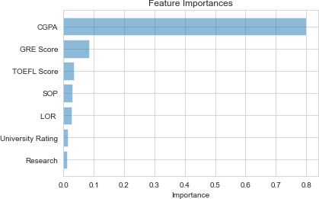
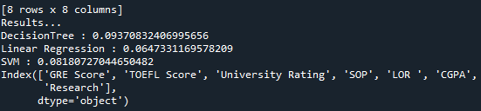

Conclusion: Thus we have studied different classification techniques.

Aim:

ASSIGNMENT 3

Assignment on Regression technique
- Apply Linear Regression using suitable library function and predict the Month-wise Download temperature data from below link. https://www.kaggle.com/venky73/temperatures- of-india?select=temperatures.csv
This data consists of temperatures of INDIA averaging the temperatures of all places month wise. Temperatures values are recorded in CELSIUS temperature.
- Assess the performance of regression models using MSE, MAE and R-Square metrics
- Visualize simple regression model.

Theory:

Regression:
Regression is a supervised learning technique which helps in finding the correlation between variables and enables us to predict the continuous output variable based on the one or more predictor variables. It is mainly used for prediction, forecasting, time series modeling and determining the causal-effect relationship between variables. In Regression, we plot a graph between the variables which best fits the given datapoints, using this plot, the machine learning model can make predictions about the data.

Terminologies Related to the Regression Analysis:

Dependent Variable: The main factor in Regression analysis which we want to predict or understand is called the dependent variable. It is also called target variable.
Independent Variable: The factors which affect the dependent variables or which are used to predict the values of the dependent variables are called independent variable, also called as a predictor.

Outliers: Outlier is an observation which contains either very low value or very high value in comparison to other observed values. An outlier may hamper the result, so it should be avoided.

Multicollinearity: If the independent variables are highly correlated with each other than other variables, then such condition is called Multicollinearity. It should not be present in the dataset, because it creates problem while ranking the most affecting variable.

Underfitting and Overfitting: If our algorithm works well with the training dataset but not well with test dataset, then such problem is called Overfitting. And if our algorithm does not perform well even with training dataset, then such problem is called underfitting.

Cost Functions:

  - Mean Absolute Error (MAE): MAE is a very simple metric which calculates the absolute difference between actual and predicted values.
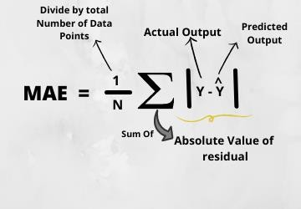

  - Mean Squared Error(MSE): Mean squared error states that finding the squared difference between actual and predicted value. we perform squared to avoid the cancellation of negative terms and it is the benefit of MSE.
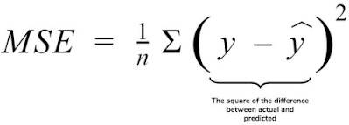
  - Root Mean Squared Error(RMSE): As RMSE is clear by the name itself, that it is a simple square root of mean squared error.

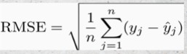

Linear Regression: Linear regression is a statistical regression method which is used for predictive analysis. It is one of the very simple and easy algorithms which works on regression and shows the relationship between the continuous variables. It shows the linear relationship between the independent variable (X-axis) and the dependent variable (Y-axis), hence called linear regression.

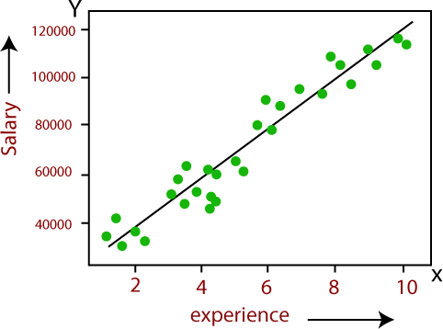
Below is the mathematical equation for Linear regression:Y= aX+b

Here, Y= Independent Variable (Target Variable), X= Dependent Variable (Predictor Variable)

Steps in Linear Regression:

- Loading the Data
- Exploring the Data
- Slicing The Data
- Train and Split Data
- Generate The Model
- Evaluate The accuracy

Code:
#Importing required libraries import matplotlib.pyplot as plt import pandas as pd
import seaborn as sns import numpy as np #Reading the input dataset
trainData = pd.read_csv("temperatures.csv")

#Print first 10 records
print(trainData.head(n=10))

#Printing datatypes and columns in the dataset #datatypes columwise
print("Below are the datatypes of columns:") print(trainData.dtypes)
print()

#column names

print("Below are the columns in the dataset:") print(trainData.columns)
print()
#describe min, max temp, count, std dev values print("Descritive information about data set:") print(trainData.describe())

#To check if dataset has null values or not
print(trainData.isnull().sum())

#To find top 10 temperature
#As per 'Annual col' find 'top 10' temp data top_10_data = trainData.nlargest(10, "ANNUAL") #Mentioned figure size plt.figure(figsize=(14,12))
plt.title("Top 10 temperature records")

#In barplot x & y axis year & temp resp
sns.barplot(x=top_10_data.YEAR, y=top_10_data.ANNUAL)

#It is found that highest record of temperature is in 2016 roughly #about 32 degree Celsius
#Analyse 2016 data
data_2016 = trainData[trainData["YEAR"]==2016]

#x axis temp data in array format
xticks = np.array(data_2016[["JAN", "FEB", "MAR", "APR", "MAY", "JUN", "JUL", "AUG", "SEP", "OCT", "NOV", "DEC"]].values)

#y axis months labels
yticks = ["JAN", "FEB", "MAR", "APR", "MAY", "JUN", "JUL", "AUG", "SEP", "OCT", "NOV", "DEC"]
#To plot the graph #Mentioned figsize plt.figure(figsize=(10,8))

#barh: xticks & yticks get and set the current tick locations and labels of the x & y-axis.
plt.barh(yticks,xticks[0])
plt.title("Month wise temperature data of 2016") plt.xlabel("Temperature in degree celsius") plt.ylabel("Month")
plt.show()

#From the above graph it is clear that May month recorded highest temperature around 35 degree celsius

#Genearate Regresion Model of Training & Testing Data
from sklearn import linear_model, metrics #train data according columns print(trainData.columns)

#x axis = year
X=trainData[["YEAR"]]

# y axis= month wise temp
Y=trainData[["JAN"]]

#import training & testing features
from sklearn.model_selection import train_test_split

#split data in training & testing part
X_train, X_test, Y_train, Y_test = train_test_split(X, Y, test_size=0.2, random_state=1) print(len(X_train)) #lenth of x-train data
print(len(X_test)) #length of y-testing data
print(trainData.shape) #Show total row & column (117,18) #Used Linear Regression Model Features to show data
reg = linear_model.LinearRegression() print(X_train)
#fit decision line in Regression Model model = reg.fit(X_train, Y_train) #Predict test data
Y_pred = model.predict(X_test)

#Year wise predtion data
print('predicted response:', Y_pred, sep='\n') #training regression model Scatter black color plots plt.scatter(X_train, Y_train, color='black')

#Blue line indicate predicted training data
plt.plot(X_train, reg.predict(X_train), color='blue', linewidth=3) plt.title("Temperature vs Year")
plt.xlabel("Year") plt.ylabel("Temperature") plt.show()

#testing regression model Scatter red color plots
plt.scatter(X_test, Y_test, color='red')

#Acc year machine predict temp
plt.plot(X_test, reg.predict(X_test), color='black', linewidth=3) plt.title("Temperature vs Year")
plt.xlabel("Year") plt.ylabel("Temperature") plt.show()

Output:
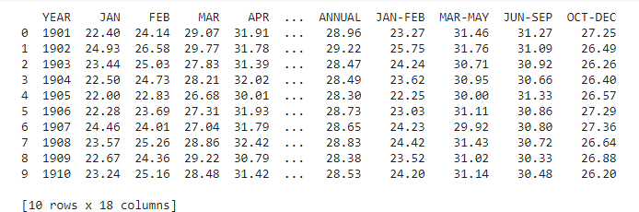
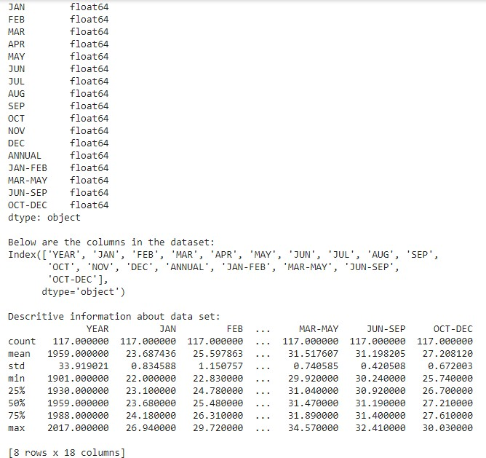
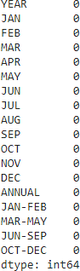

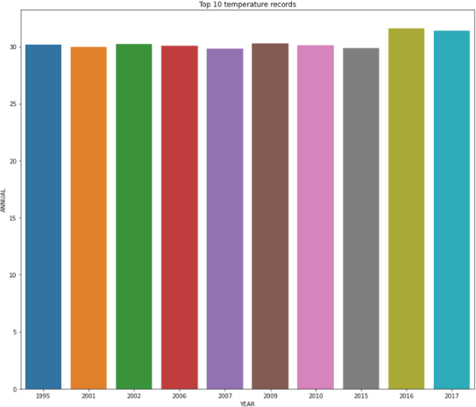
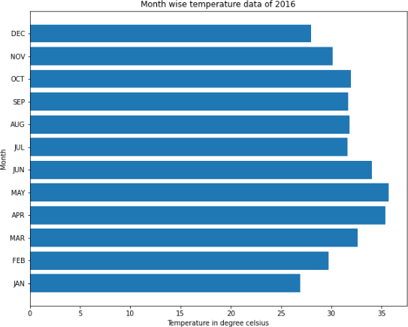
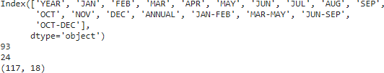

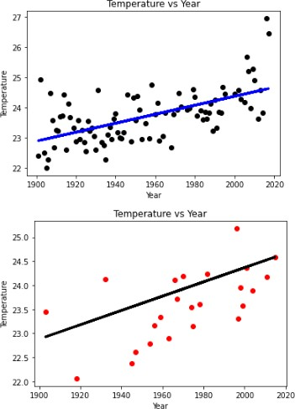

Conclusion: Thus we have studied Regression techniques.

Aim:

ASSIGNMENT 4

Assignment on Clustering Techniques
Download the following customer dataset from below link: Data Set: https://www.kaggle.com/shwetabh123/mall-customers

This dataset gives the data of Income and money spent by the customers visiting a Shopping Mall. The data set contains Customer ID, Gender, Age, Annual Income, Spending Score. Therefore, as a mall owner you need to find the group of people who are the profitable customers for the mall owner. Apply at least two clustering algorithms (based on Spending Score) to find the group of customers.
- Apply Data pre-processing (Label Encoding , Data Transformation….) techniques if necessary.
- Perform data-preparation( Train-Test Split)
- Apply Machine Learning Algorithm
- Evaluate Model.
- Apply Cross-Validation and Evaluate Model

Theory:
Approach of Clustering : Clustering or cluster analysis is a machine learning technique, which groups the unlabelled dataset. It can be defined as "A way of grouping the data points into different clusters, consisting of similar data points. The objects with the possible similarities remain in a group that has less or no similarities with another group
Applications of Clustering: Market Segmentation, Statistical data analysis, Social network analysis, Image segmentation, Anomaly detection, etc.

K-Means Clustering:
K-Means clustering is the most popular unsupervised learning algorithm. It is used when we have unlabelled data which is data without defined categories or groups. The algorithm follows an easy or simple way to classify a given data set through a certain number of clusters, fixed apriori.

K-Means Algorithm:

- Step-1: Select the number K to decide the number of clusters.

- Step-2: Select random K points or centroids. (It can be other from the input dataset).
- Step-3: Assign each data point to their closest centroid, which will form the predefined K clusters.
- Step-4: Calculate the variance and place a new centroid of each cluster.
- Step-5: Repeat the third steps, which means reassign each datapoint to the new closest centroid of each cluster.
- Step-6: If any reassignment occurs, then go to step-4 else go to FINISH.
- Step-7: The model is ready.

K-Means Clustering Intuition:

- Centroid: A centroid is a data point at the centre of a cluster. In centroid-based clustering, clusters are represented by a centroid. The algorithm requires number of clusters K and the data set as input. The data set is a collection of features for each data point. The algorithm starts with initial estimates for the K centroids.
- Data Assignment Step: Each centroid defines one of the clusters. In this step, each data point is assigned to its nearest centroid, which is based on the squared Euclidean distance. So, if ci is the collection of centroids in set C, then each data point is assigned to a cluster based on minimum Euclidean distance.
- Centroid update Step: In this step, the centroids are recomputed and updated. This is done by taking the mean of all data points assigned to that centroid’s cluster.
- Choosing the value of K: The K-Means algorithm depends upon finding the number of clusters and data labels for a pre-defined value of K. We should choose the optimal value of K that gives us best performance. There are different techniques available to find the optimal value of K. The most common technique is the elbow method.
- The elbow method: The elbow method is used to determine the optimal number of clusters in K- means clustering.
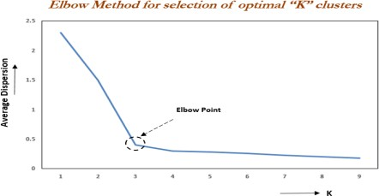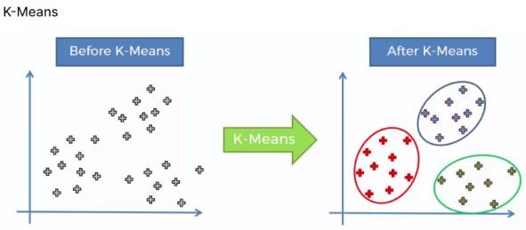

- WCSS List: Elbow method uses the concept of WCSS value. WCSS stands for Within Cluster Sum of Squares, which defines the total variations within a cluster. To find the optimal value of clusters, the elbow method follows the below steps:

Python Implementation of K-means Clustering Algorithm

- Data Pre-processing
- Finding the optimal number of clusters using the elbow method
- Training the K-means algorithm on the training dataset
- Visualizing the clusters

Code:

#Import required libraries import pandas as pd
# Visualization Library import matplotlib.pyplot as plt
from matplotlib.lines import Line2D # Scaling
from sklearn.preprocessing import StandardScaler # Dimensional
from sklearn.decomposition import PCA # Clustering
from sklearn.cluster import KMeans #import numpy as np
#import seaborn as sns

#Load Data csv file
data = pd.read_csv('Mall_Customers.csv') #Data Preprocessing Steps
print('For printing sample data:') print(data.head())
print() #for creating blank space print('To get total rows and columns:') print(data.shape)
print()
#Column names, Count, Data Types, Null Values print('To get info about columns:') print(data.info())
print()
#Rename column name
data.rename(columns = {'Genre':'Gender'} , inplace = True) #Describe Datasets
print(data.describe()) print()
#Drop useless columns
data.drop(labels = 'CustomerID' , axis = 1 , inplace = True) #Missing values
print(data.isnull().sum()) print()

#Encoding finding data types of data present in csv print(data.dtypes)
print()
#Find Gender Counts print(data['Gender'].value_counts()) #Consider Male=1 & Female=0
data['Gender'].replace({'Male':1 , 'Female':0} , inplace = True) print(data.info())
#Scaling
#Clustering algorithms such as K-means do need feature scaling before they are fed to the algorithm. # Since, clustering techniques use Euclidean Distance to form the cohorts,
#it will be wise to scale the variables.
#Data coverted into normalization distribution sc = StandardScaler()
data_scaled = sc.fit_transform(data) #Dimensionality reduction
pca = PCA(n_components = 2)
data_pca = pca.fit_transform(data_scaled) print("data shape after PCA :",data_pca.shape) print("data_pca is:",data_pca)
# KMeans Clustering
''' Elbow plot Details : Finding optimal value of clusters K is a hyperparameter in KMeans algorithm.

WCSS : Within Cluster Sum of Squares, in other word it's sum of squared distance between each point and the centroid in a cluster
Lower WCSS shows a better clustering(because points in a cluster are more similar to each other, this is what we want)
Increasing the k value always results in a lower WCSS.
if we put k to be equal to the number of samples(so each point is a special cluster) then WCSS = 0 , but this is not a wise way.
Here we will use elbow plot to find the best k. Elbow point will show the best k.
How to find this point ?
After this point the speed of WCSS decreasing will be lowered. ''' #font size
plt_font = {'family':'serif' , 'size':16}
'''WCSS: Within Cluster Sum of Squares, in other word it's sum of squared distance between each point and the centroid in a cluster
Lower WCSS shows a better clustering(because points in a cluster are more similar to each other, this is what we want)
Increasing the k value always results in a lower WCSS.''' #Create blank list
#Minimum no. of clusters & squared distance wcss_list = []
for i in range(1, 15):
kmeans = KMeans(n_clusters = i , init = 'k-means++' , random_state = 1)

kmeans.fit(data_pca) wcss_list.append(kmeans.inertia_)
#Draw Elbow plot #X & Y axis range
plt.plot(range(1,15) , wcss_list)
plt.plot([4,4] , [0 , 500] , linestyle = '--' , alpha = 0.7) #Elbow line
plt.text(4.2 , 300 , 'Elbow = 4') #X & Y axis labels
plt.xlabel('K' , fontdict = plt_font) plt.ylabel('WCSS' , fontdict = plt_font) plt.show()
#KMeans Algorithm
kmeans = KMeans(n_clusters = 4 , init = 'k-means++' , random_state = 1) kmeans.fit(data_pca)
cluster_id = kmeans.predict(data_pca) result_data = pd.DataFrame() result_data['PC1'] = data_pca[:,0] result_data['PC2'] = data_pca[:,1] result_data['ClusterID'] = cluster_id #KMeans clustered ploting features #cluster colors & tab details
cluster_colors = {0:'tab:red' , 1:'tab:green' , 2:'tab:blue' , 3:'tab:pink'}

cluster_dict = {'Centroid':'tab:orange','Cluster0':'tab:red' , 'Cluster1':'tab:green'
, 'Cluster2':'tab:blue' , 'Cluster3':'tab:pink'} #Scatter data
#X & Y Value, result & cluster colors
plt.scatter(x = result_data['PC1'] , y = result_data['PC2']
, c = result_data['ClusterID'].map(cluster_colors))
handles = [Line2D([0], [0], marker='o', color='w', markerfacecolor=v, label=k, markersize=8) for k, v in cluster_dict.items()]
plt.legend(title='color', handles=handles, bbox_to_anchor=(1.05, 1), loc='upper left') plt.scatter(x = kmeans.cluster_centers_[:,0] , y = kmeans.cluster_centers_[:,1] ,
marker = 'o' , c = 'tab:orange', s = 150 , alpha = 1) #Heading details
plt.title("Clustered by KMeans" , fontdict = plt_font) plt.xlabel("PC1" , fontdict = plt_font) plt.ylabel("PC2" , fontdict = plt_font)
#Show all data plt.show()

Output: 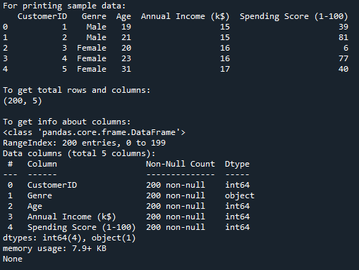

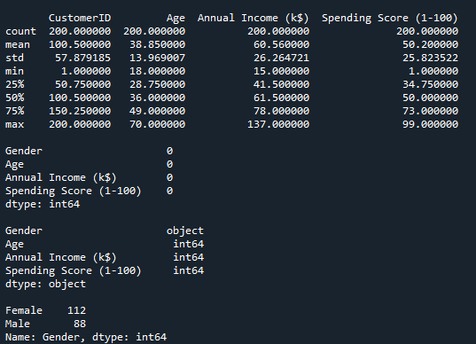
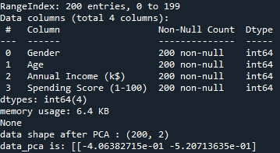
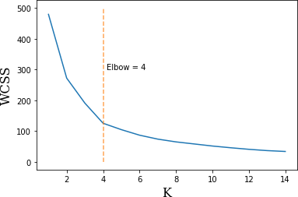
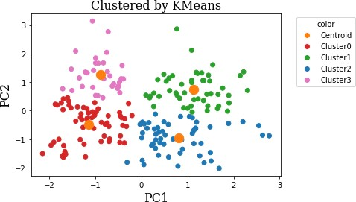

Conclusion: Thus we have studied Clustering techniques.

Aim:

ASSIGNMENT 5

Assignment of exploring Machine Learning libraries.
Demonstrate multiple methods of Machine Learning libraries like NumPy & Pandas. Perform multiple operations on given dataset. Below is the link of dataset
https://olympus.greatlearning.in/courses/10899/files/1753546?module_item_id=903335

Theory:

NumPy:

NumPy is a Python package. It stands for 'Numerical Python'. It is a library consisting of multidimensional array objects and a collection of routines for processing of array.

Operations using NumPy:

Using NumPy, a developer can perform the following operations −
  - Mathematical and logical operations on arrays.
  - Fourier transforms and routines for shape manipulation.
  - Operations related to linear algebra. NumPy has in-built functions for linear algebra and random number generation.

Methods of Numpy:

  - np.array: This method useful for creating one & multidimensional array.

import numpy as np  n1=np.array([10,20,30,40]) n1 | import numpy as np n2=np.array([[10,20,30,40],[40,30,20,10]])  n2

  - np.zeros: Returns a new array of specified size, filled with zeros.

import numpy as np n1=np.zeros((1,2))  n1 | import numpy as np n1=np.zeros((5,5))  n1

  - np.arrange: Return records in given order. import numpy as np
n1=np.arange(10,20) n1

  - np.full: Return full array according given dimensions. import numpy as np
n1=np.full((2,2),10) n1

  - np.random.randint: Return random values in given range. import numpy as np
n1=np.random.randint(1,100,5) n1

  - n1.shape: Return number of rows & columns in given array.
n1.shape

- np.sum: Return sum of the array. import numpy as np n1=np.array([10,20]) n2=np.array([30,40]) np.sum([n1,n2])

- np.equal: Check similarities of values in given array.
import numpy as np
n1=np.array([10,20,30])
n2=np.array([10,30,20]) np.equal(n1,n2)
- np.vstack/ np.hstack/np.column_stack: Return multiple arrays in vertical, horizontal & column
format.

import numpy as np  n1=np.array([10,20,30])  n2=np.array([40,50,60])  np.vstack((n1,n2)) |  | import numpy as np  n1=np.array([10,20,30])  n2=np.array([40,50,60])  np.hstack((n1,n2)) |  | import numpy as np  n1=np.array([10,20,30])  n2=np.array([40,50,60])  np.column_stack((n1,n2))

NumPy Manipulations:

#Division:  import numpy as np n1=np.array([10,20,30]) n1=n1/2  n1 | #Intersection:  import numpy as np  n1=np.array([10,20,30,40,50,60])  n2=np.array([50,60,70,80,90])  np.intersect1d(n1,n2) | #Difference:  import numpy as np  n1=np.array([10,20,30,40,50,60])  n2=np.array([50,60,70,80,90])  np.setdiff1d(n1,n2)

- PANDAS:

Pandas is a Python library used for working with data sets. It has functions for analyzing, cleaning, exploring, and manipulating data. The name "Pandas" has a reference to both "Panel Data", and "Python Data Analysis" and was created by Wes McKinney in 2008.

Why Use Pandas? A panda allows us to analyze big data and make conclusions based on statistical theories. Pandas can clean messy data sets, and make them readable and relevant.

Methods of Pandas:

- pd.Series: A Pandas Series is like a column in a table. It is a one-dimensional array holding data of any type. With the index argument, you can name your own labels.

import pandas as pd s1=pd.Series([1,2,3,4,5]) s1 |  | import pandas as pd s1=pd.Series([1,2,3,4,5],index=['a','b',' c','d','e'])  s1 |  | import pandas as pd pd.Series({'a':10,'b':20,'c':30})

- pd.DataFrame: A Pandas DataFrame is a 2 dimensional data structure, like a 2 dimensional array, or a table with rows and columns.

import pandas as pd pd.DataFrame({"Name":['Bob','Sam','Anne'],"Marks":[76,25,92]})

- pd.read_csv: A simple way to store big data sets is to use CSV files (comma separated files). CSV files contain plain text and are a well know format that can be read by everyone including Pandas.

import pandas as pd iris=pd.read_csv('iris.csv')

- head(): Returns the headers and a specified number of rows, starting from the top.
iris.head()

- tail(): Returns the headers and a specified number of rows, starting from the bottom.
iris.tail()

- shape(): Return number of rows & colums count.
iris.shape

- describe(): Return more information about the data set
iris.describe()

- min(): Return minimum value in each columns. iris.min()
- max(): Return maximum value in each columns.

iris.max()

10.iloc[]: Return one or more specified row(s)

iris.iloc[0:3,0:2]

Output:
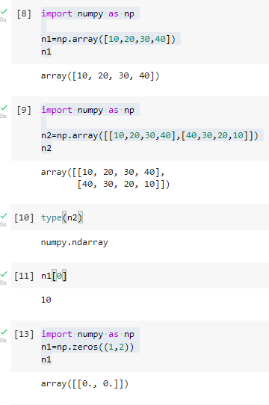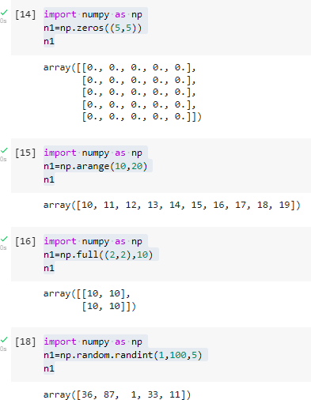

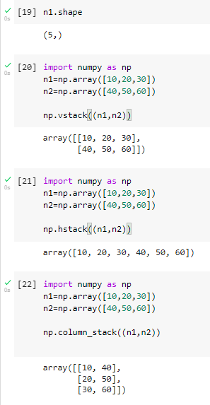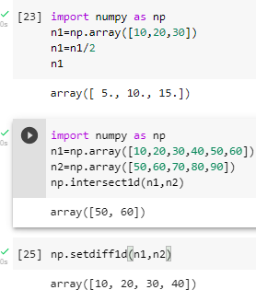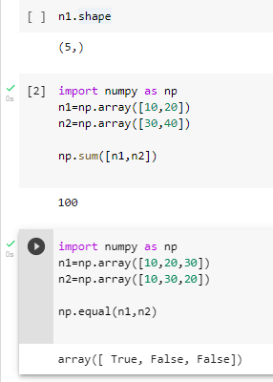

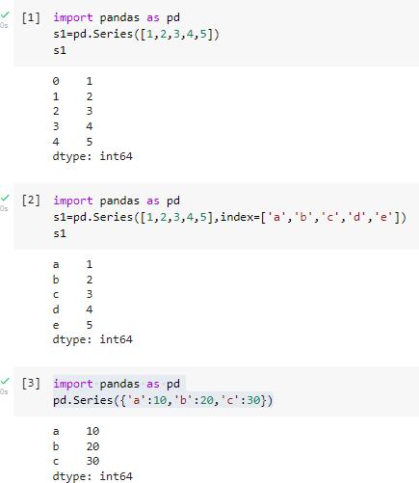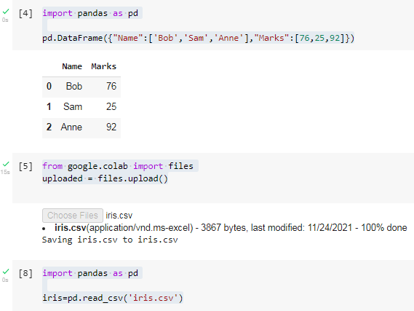

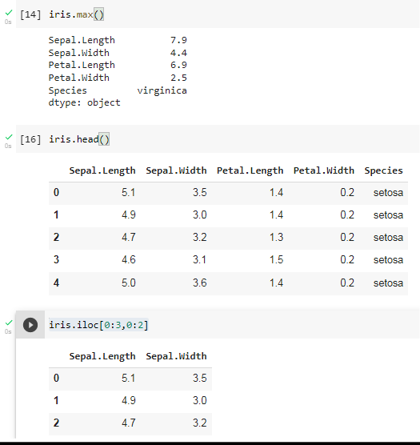
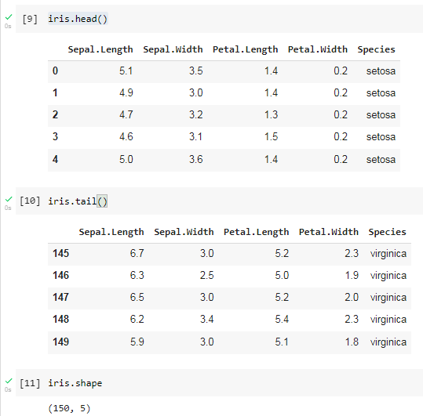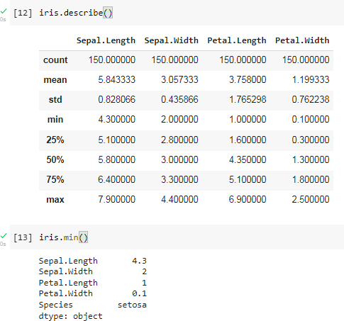

Conclusion: Thus we have studied differe

nt methods in machine learning libraries.

